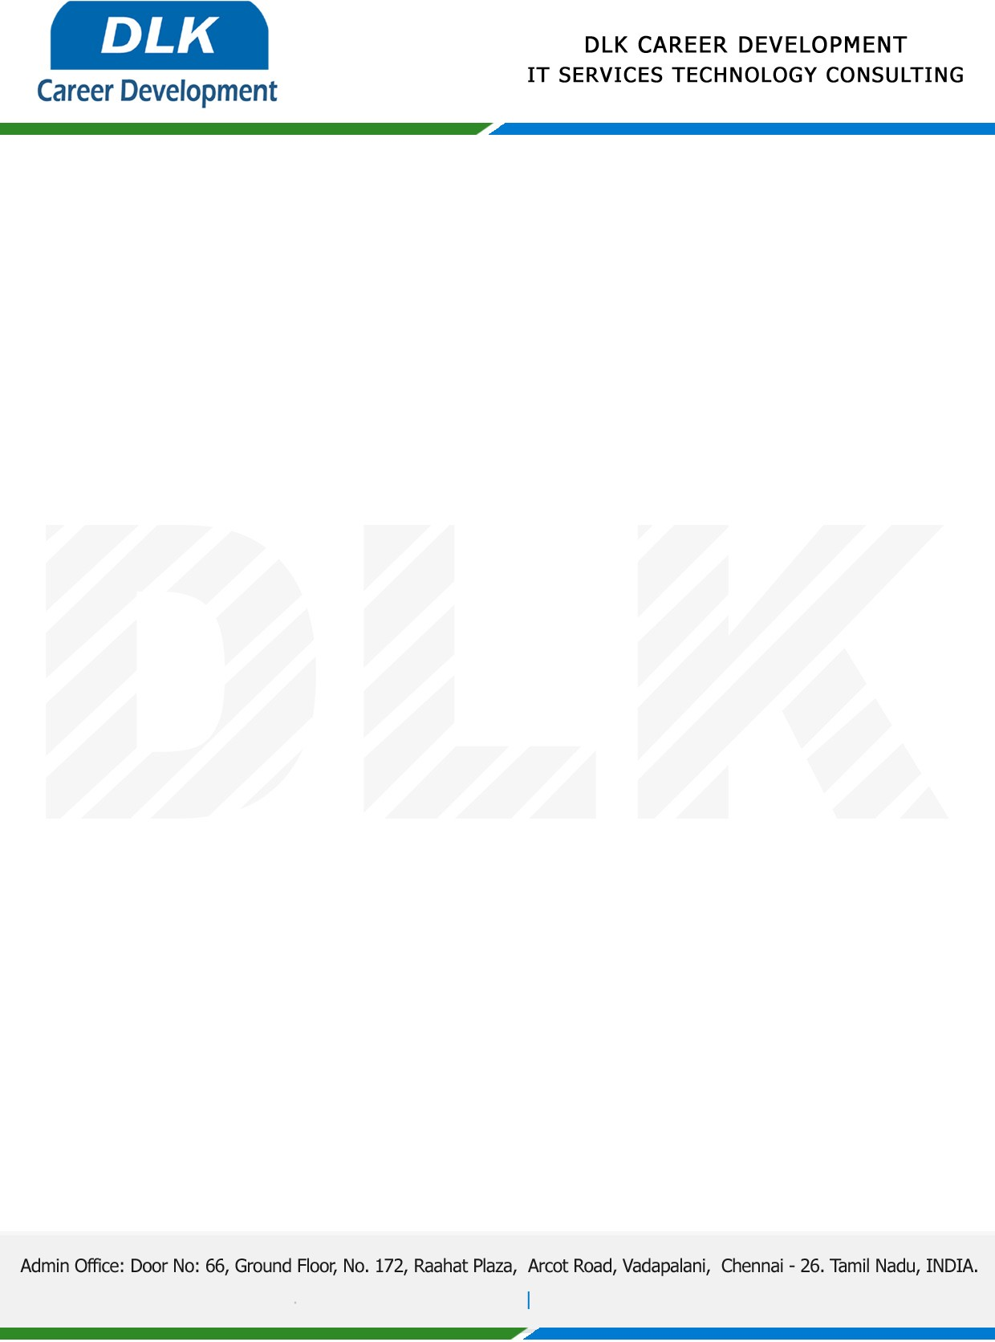

Date: 01 / December/ 2022

**To**

Department of MCA ([Computer Application),](https://www.cseindia.org/)

Head of Department,

Dr.MGR Educational & Research Institute, Chennai - 600095.

**Sub: Letter of Project Acceptance**

This is to certify that **MR SUBIN KUMAR K (REG NO: 214012101209)** that final year student of has accepted his Project Work duration from **December 2022** to **March 2023** under the domain **“Cloud Computing”.** During the internship, all information and data collected from you should be kept confidential.

**Topic:** Revocable Identity-Based Broadcast Proxy re-encryption for data sharing.

We appreciate your interest in **DLK CAREER DEVELOPMENT**

